Qbeast
- Qbeast is an open-source data format built on top of Apache Spark that provides multi-dimensional indexing, efficient data skipping, and faster query performance. It is particularly useful for handling large analytical workloads by reducing the amount of data scanned during queries.
- Qbeast is a Data Lakehouse optimization product that improves cost efficiency and accelerates queries through superior data layout and cloud integration.
- Qbeast targeting the speed-up of analytics and AI workloads while significantly reducing computing costs.
Key Advantages:
- Multi-dimensional Indexing: Uses a tree structure to efficiently organize and query data.
- Automatic Layout Optimization: Continuously monitors and optimizes data distribution and indexing.
- Multi-Cloud Support: Available as an open-source project with deployments on Amazon Web Services, Google Cloud, and Microsoft Azure Cloud.
- Platform-agnostic: Works the major open table formats: Delta Lake, Apache Iceberg and Apache Hudi and query platforms that support them, including Apache Spark, Trino, Databricks, and many more.
- Principled Sampling: Provides fast and statistically representative approximate query results without loading entire datasets.
Installation & Setup
Prerequisites:
• Apache Spark 3.x
• Scala 2.12 / Java 8 or higher
• sbt for Scala builds
Steps to Install:
1. Clone the Qbeast repository: git clone https://github.com/Qbeast-io/qbeast-spark
2. Build using sbt: sbt package
3. Add the generated JAR to Spark with --jars option or place it in the Spark jars directory.
Configuration:
• Ensure SparkSession is initialized with Qbeast support:
spark = SparkSession.builder \
.appName("QbeastExample") \
.config("spark.sql.extensions", "io.qbeast.spark.sql.QbeastSparkSessionExtension")\
.getOrCreate()
Core Concepts
Qbeast Format
Qbeast Format is a data storage format built on top of Apache Spark that:
- Stores data in an indexed structure.
- Uses multi-dimensional indexes on selected columns (the ones you configure, e.g., customer_id, region, etc.).
- Optimizes queries by skipping irrelevant data blocks, so Spark scans only the portions needed.
- Works similarly to Delta Lake or Iceberg in terms of integration with Spark, but its unique advantage is indexing for faster reads.
Example:
If you store 1TB of data but only query 5% of it regularly (say, filtering by region = 'EU'), Qbeast’s indexing ensures Spark only scans that 5% instead of the whole dataset — huge performance boost.

Qbeast’s OTree Algorithm
The O-Tree (Ordered Tree) is the core indexing algorithm used by Qbeast to store and organize data efficiently. It enables multi-dimensional indexing, sampling, and data skipping.
The two primary goals of the OTree algorithm are
- enable spatial datasets with multi-dimensional indexing.
- empower the query engine with optimized sampling operators, that is, the ability to retrieve a statistically significant fraction of the dataset without reading all the data.
Multi-dimensional indexing
One of the most important techniques used to build a multi-dimensional index is through recursive space division

Recursive space division
- The algorithm starts with a bounded vector space that contains all the data.
- This space is recursively divided into smaller, equal-sized, non-overlapping subspaces (cubes) whenever a cube exceeds a predefined capacity(Cap) (desiredCubeSize).
- For n indexed columns, the space is divided into 2^n cubes.
- Example:
- With two columns (x, y) and cube capacity = 2, the space is split into 4 sub-cubes.
- Cubes keep splitting until each cube holds(size) ≤ capacity(Cap).
- Each cube’s boundaries define which elements it can store.

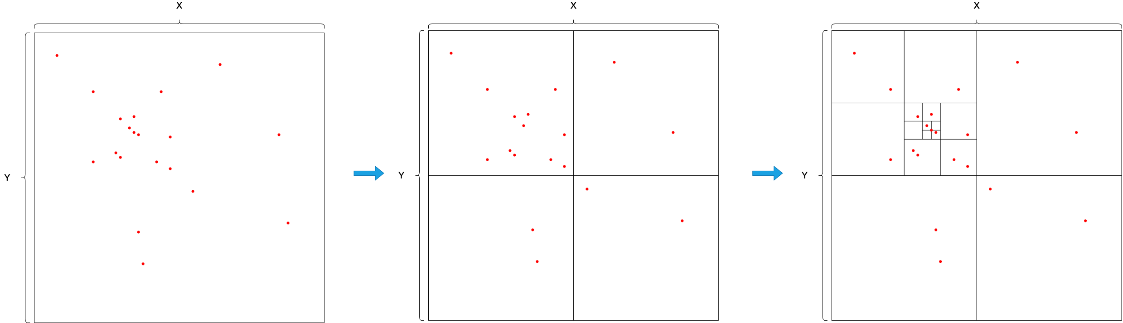
Root Cube Child Cubes top left child cubes

This recursive division builds a tree-like structure where cubes = tree nodes
The figure below shows a treelike representation of the above example. Each square represents a cube, with green cubes that satisfy the requirement size ≤ cap and red ones that don't.
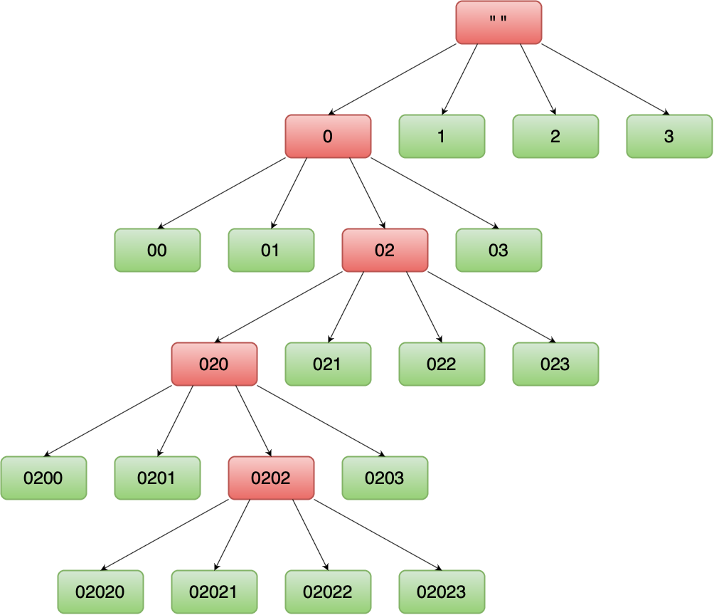

Efficient Data Sampling
- Traditional sampling loads the entire dataset, then randomly picks a subset → inefficient to scale data.
- O-Tree integrates sampling into its structure:
  - Each cube contains a random subset of data.
  - Sampling is controlled via a parameter called maxWeight, which defines what fraction of data each cube holds
- Result: Sampling operators can directly read only relevant cubes → faster queries with representative subsets.

O-Tree Index
- The index is built into the tree structure itself → no separate index is needed.
- Each cube contains actual data (payload) and is enriched with:
  - weight: Random integer assigned to elements, used to order them for sampling.
  - maxWeight: Defines the fraction of data retained in the cube(the largest weight from all elements contained in a cube's payload).
  - payload: The elements stored in the cube.
  - offset: Extra elements when payload exceeds cube size.
- Data is automatically organized to support both indexing & sampling simultaneously.

General READ Protocol(getting data)
- Input: desired sampling fraction f.
- Start at root cube
- Traverse the tree DFS (depth-first search) from the root – Prioritize children over siblings
- Stop going deeper when cube has maxWeight > f.
- Decide which cubes to include based on their state and relationship to f.
- Collect all relevant cubes → read them only.
If f =0.3 30% of the dataset3
General WRITE Protocol(Adding data)
- Input: element E(a, b | w) with values (a, b) for indexed columns and random weight w.
  - a,b Coordinates Values in indexed columns(x,y)
  - w random weight assigned to element
- Start at the root cube
- Traverse from the root cube to the correct child cube based on (a, b).
- Check Maxweight of cube
  - If Maxweight > w:
    - Write the Element into the cube
    - If Cube is full you might push the max element out and update maxweight
  - If Maxweight < w:
    - Move to correct child cube and repeat the check
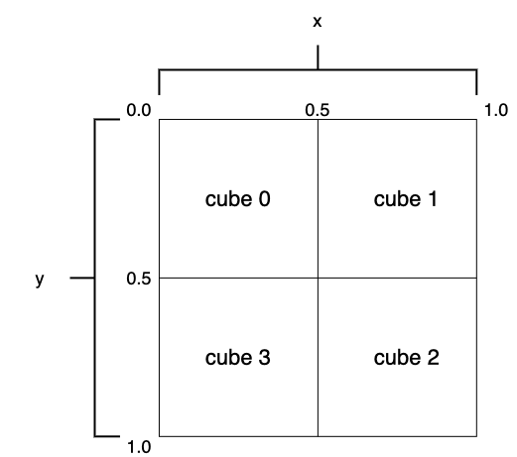

Qbeast Core Technology
Qbeast integrates with Apache Spark through qbeast-spark, a core library that enhances data management and query performance in the modern data lakehouse.
At its core, Qbeast partitions datasets into smaller cubes organized into a multi-dimensional tree structure (O-Tree). This allows queries to skip irrelevant cubes and focus only on the relevant data segments, dramatically improving query speed. Automatic indexing and seamless integration of new data reduce administrative overhead for data engineers.
Apache Spark Integration
Qbeast-Spark is the bridge between Spark and Qbeast. It integrates into existing Spark environments without requiring major changes to pipelines or infrastructure. By acting as both a data source and sink, Qbeast-Spark unlocks advanced features for data indexing, sampling, and query acceleration.
Key Features of Qbeast-Spark
- Multi-column indexing
  - Indexes multiple columns simultaneously, reducing query times.
  - Especially powerful for complex queries with joins and filters, as only relevant data cubes are scanned.
  - Functions like an intelligent catalog system for your lakehouse.
- Efficient data sampling
  - Supports approximate queries using statistically representative samples.
  - Ideal for exploratory analysis, machine learning, and iterative workloads.
  - Saves time and computational resources by avoiding full table scans.
Benefits of Qbeast-Spark
- Accelerated query execution: Multi-column indexing and cube-based pruning make queries much faster.
- Reduced data transfer: Only the necessary data is scanned, minimizing I/O costs.
- Cost efficiency: Optimized resource usage translates to lower infrastructure costs.
- Enhanced data exploration: Fast, approximate sampling empowers analysts and data scientists to test hypotheses quickly.
- Open-source collaboration: Qbeast-Spark is community-driven, allowing contributions, improvements, and transparency.

QbeastTable API
The QbeastTable API allows you to interact directly with Qbeast tables to explore metadata, revisions, and optimize their layout. This API is particularly useful for:
- Inspecting index information (revisions, indexed columns, cube size).
- Measuring indexing efficiency through metrics.
- Executing optimization operations for better query performance.
Scala
import io.qbeast.table.QbeastTable
val qbeastTable = QbeastTable.forPath(spark, "path/to/qbeast/table")
Table Information
- Data in a Qbeast table is organized into Revisions.
- Each Revision is defined by:
  - Indexed columns
  - Transformers / transformations
  - Cube sizes
- A new Revision is created whenever these parameters change (e.g., adding new data that exceeds boundaries).

Useful API’s
qbeastTable.allRevisions() // List all revisions
qbeastTable.allRevisionIDs() // List revision identifiers
qbeastTable.indexedColumns() // Indexed columns of latest revision
qbeastTable.cubeSize() // Cube size of latest revision
Index Metrics
Index metrics provide insights into the structure and efficiency of the index for a given revision.
Scala
val metrics = qbeastTable.getIndexMetrics()
println(metrics)
Example Output (summarized):
- revisionId: 1
- elementCount: 309,008
- dimensionCount: 2
- desiredCubeSize: 3000
- indexingColumns: price:linear, user_id:linear
- cubeCount: 230
- blockCount: 848
- fileCount: 61
Metrics also include:
- Multi-block file stats (distribution of elements per cube/block).
- Depth-wise cube stats (distribution of cubes across tree depth).

Table Operations – Optimization
Over time, as new data is added, the layout diverges from optimal.
Qbeast provides an optimize() method to reorganize data files for better performance.
Parameters:
- revisionID: revision to optimize (default: latest).
- filePaths: specific files to optimize.
- fraction: portion of the revision to optimize (default: 1.0).
- options: additional config (metadata, hooks).
Optimization Modes:
- FULL_TABLE → optimize all revisions.
- FULL_REVISION → optimize all data in a given revision.
- REVISION_FRACTION → optimize part of a revision (fraction).
- REVISION_FILES → optimize selected files in a revision.
- TABLE_FILES → optimize specific files across revisions.

Columns To Index Selector
Qbeast organizes records using a multi-dimensional index, which is built on a subset of the table’s columns.
- Prior to v0.6.0 → the user had to manually define columnsToIndex.
- From v0.6.0 onward → columns can be selected automatically by enabling the Columns To Index Selector.
Enabling Automatic Column Index Selection
bash
--conf spark.qbeast.index.columnsToIndex.auto=true \
--conf spark.qbeast.index.columnsToIndex.auto.max=10
SparkColumnsToIndexSelector
The default implementation provided is SparkColumnsToIndexSelector, designed for Spark DataFrames.
Steps performed:
- Convert timestamp columns to Unix timestamps.
- Encode string columns numerically using StringIndexer.
- Use VectorAssembler to combine all features.
- Compute a correlation matrix.
- Calculate absolute correlations for each column.
- Select the top N columns with the lowest average correlation → best suited for indexing.
Best Practices for Manual Column Selection
When choosing columns to index in Qbeast manually, keep these guidelines in mind:
- Index columns frequently used in filters
  - Prioritize columns that appear in WHERE, GROUP BY, or JOIN conditions.
  - Example: If most queries filter by region and product_id, index those first.
- Choose columns with high selectivity
  - Selectivity = how much a column helps narrow down results.
  - Example: customer_id is more selective than country.
  - High selectivity = better data skipping = faster queries.
- Balance cardinality
  - Avoid indexing columns with very low cardinality (e.g., gender, boolean), since they won’t prune much data.
  - Also avoid very high cardinality (e.g., unique UUIDs), since each value is almost unique → poor index efficiency.
  - Target medium cardinality columns (hundreds → thousands of unique values).
- Limit the number of indexed columns
  - Indexing too many columns increases storage and indexing overhead.
  - Rule of thumb: Index 2–4 columns that drive most queries.

Difference from Delta Lake / Iceberg with Qbeast
Qbeast
- Focuses on multi-dimensional indexing and efficient data skipping.
- Optimized for query acceleration and sampling.
- Best suited for analytics, ML, and exploratory workloads where speed and approximate results matter.

Delta Lake & Apache Iceberg
- Focus more on ACID transactions, schema evolution, and versioning.
- Provide strong guarantees for data reliability, consistency, and time travel.
- Best suited for ETL pipelines, OLTP-like workloads, and production-grade Lakehouse operations.

Usage Examples
Pyspark

from pyspark.sql import SparkSession
# Start Spark with Qbeast extension
spark = SparkSession.builder \
.appName("QbeastSamplingExample") \
.config("spark.sql.extensions", "io.qbeast.spark.sql.QbeastSparkSessionExtension") \
.getOrCreate()
# Example DataFrame
data = [
("EU", 101, 500.0),
("EU", 102, 200.0),
("US", 201, 300.0),
("ASIA", 301, 100.0),
("EU", 103, 400.0),
("US", 202, 150.0),
]
df = spark.createDataFrame(data, ["region", "product_id", "amount"])

# Write with Qbeast format, indexing on region and product_id
df.write.format("qbeast") \
.option("columnsToIndex", "region,product_id") \
.save("qbeast_table")
# Read with Qbeast
qdf = spark.read.format("qbeast").load("qbeast_table")
# Example: Sampling 10% of data directly using O-Tree indexing
sampled = qdf.sample(0.1)
# Perform an aggregation on the sampled data
result = sampled.groupBy("region").avg("amount")
result.show()

Performance Comparision – Delta Lake vs Qbeast
Dataset: 1 TB Sales Transactions
Indexed Columns (Qbeast): region, product_id, timestamp

Query 1 – Point Filter
SELECT * FROM sales WHERE region = 'EU';
Delta Lake:
- Query Time: 45 sec
- Data Scanned: 300 GB
Qbeast:
- Query Time: 8 sec
- Data Scanned: 30 GB

Query 2 – Multi-column Filter
SELECT * FROM sales WHERE region = 'EU' AND product_id = 123;
Delta Lake:
- Query Time: 60 sec
- Data Scanned: 400 GB
Qbeast:
- Query Time: 12 sec
- Data Scanned: 20 GB

Query 3 – Aggregation
SELECT region, AVG(amount) FROM sales GROUP BY region;
Delta Lake:
- Query Time: 75 sec
- Data Scanned: 600 GB
Qbeast:
- Query Time: 18 sec
- Data Scanned: 80 GB

Query 4 – Sampling Query
qdf.sample(0.1).groupBy("region").avg("amount")
Delta Lake:
- Query Time: 90 sec
- Data Scanned: 1 TB (full scan)
Qbeast:
- Query Time: 10 sec
- Data Scanned: 100 GB (10% only)

References
• Official Qbeast Documentation: https://qbeast.io/
• GitHub Repo: https://github.com/Qbeast-io/qbeast-spark

